**Comparative Analysis on Bamboo Classification: Supervised Learning Techniques with points and polygon datasets in GEE**

**Dr. K. Srinivas1*, Dr. K. K. Sarma3, Dr. M. S. R. Murthy4, K. Veena Madhuri2, V. Tanmai2, N. C. V. S. Sai Chandana2**

1*Professor, Department of CSE, V R Siddhartha Engineering College, Vijayawada, India, vrdrks@mail.vrsiddhartha.ac.in

2Student, Department of CSE, V R Siddhartha Engineering College, Vijayawada, India

3Dr. K. K. Sarma, Scientist/Engineer-SG, [North Eastern Space Applications Centre, Department of Space, Umiam, India.](https://www.researchgate.net/institution/North_Eastern_Space_Applications_Centre_NESAC)

4Dr. M. S. R. Murthy, Research Advisor, V R Siddhartha Engineering College, Vijayawada, India

**Abstract:** Bamboo is an important resource in terms of both economic and environmental advantages. It is a naturally fast-growing plant that has several applications in the paper industry, medicine, and construction. The North Eastern area of India has been one of the world's centres of bamboo resources for a long time. Adequate initiation and good resource management are required to specifically select bamboo growing sites. Remote sensing technologies and Geographic Information Systems along with image classification algorithms have proven particularly useful in detecting land use and land cover changes, and as a result, they are also important in bamboo mapping and classification. Google Earth Engine (GEE) is one of the greatest platforms for performing classification analysis in addition to ideal visualization. In this frame work, apply the four different supervised learning algorithms namely Naive Bayes (NB), Minimum Distance, Classification and Regression Trees (CART), and Random Forest (RF) to classify the Bamboo by using Sentinel 2 satellite images. Karbi Anglong District and Dima Hasao, district of Assam, India are considered for training and testing respectively. This paper presents a comparative analysis of the above four supervised algorithms for land cover classification with six class labels namely Pure bamboo, Dominated bamboo, Mixed bamboo, Water, Forest and Fallow land using polygons and points in Google Earth Engine. The point plots are taking in rough area but the polygon plots are taking in a defined area to examine the closeness of the regions. The polygon-based classification provides a more comprehensive representation of land cover features compared to point-based classification. This difference affects the accuracy of each method when points and polygons are considered. This study also includes a comparison of the regions of each class with their ground truth values. Comparative analysis results shows that the CART and Random forest attained higher accuracy of 94.78% and 94.98% and were given the most accurate classification of 6 different classes.

**Keywords:** Bamboo Classification, Supervised learning, Random Forest (RF), Naive Bayes, Minimum Distance, Classification And Regression Tree (CART); Google Earth Engine (GEE), Sentinel -2

**1. Introduction**

Bamboo, as the largest member of the grass family Poaceae, plays an important role in local economies throughout the world. They are used in furniture and construction, or as food for human and animals like panda. Bamboo is a versatile crop. It can be used in 1,500 different ways including as food, a substitute for wood, building and construction material, for handicrafts and paper. It can grow only in sub-tropic areas or in regions with extremely cold climates. Around 80 per cent of bamboo forests lie in Asia with India, China and Myanmar having 19.8 million hectares of bamboo. India is the world’s second largest cultivator of bamboo after China, with 136 species and 23 genera spread over 13.96 million hectares. More than 7,000 years of written history mention items made of bamboo, including arrows, paper, books, and building supplies. It is a great resource because of its history, how it is used today, and how economically sustainable the plant is.

There are around 1,400 different species of bamboo to provide a glimpse of range that is accessible. The smallest can only reach heights of four to six inches, while the tallest can reach 130 feet. A bamboo stalk reaches its full height and width in one growth season, regardless of the final height. Bamboo is a very significant natural resource among the many different plant types found around the planet. Bamboo is well recognized for its flexibility, having a brief advancement life cycle and astoundingly quick development. A wide extent of situations and climatic conditions can back bamboo species. In spite of the fact that tropical and subtropical areas regularly back tall levels of bamboo differing qualities, they can be found in an assortment of situations, counting damp deciduous, tropical, and calm zones. There are 87 general and over 1500 species of bamboo worldwide. With the exception of Antarctica and Europe, bamboo resources aren't spread equitably throughout continents. With almost 900 bamboo species under 65 taxa, Asia has particularly rich bamboo resources.

The dominant forest species in one area define the spectral signature acquired by the remote sensing scanner, allowing for simple identification utilizing this spectral signature. But so far, the majority of bamboo species do not dominate the canopy. They are members of the understorey vegetation and are concealed beneath the ecosystem canopy. Because only a portion of the reflected radiation from the understorey vegetation might be captured by a remote sensing device, it would be significantly more challenging to identify them through direct spectral signature analysis. This has led to the suggestion of indirect mapping techniques to map the spread of the understorey vegetation. The idea behind this indirect mapping technique is to leverage the ecological connection between a species' surroundings and its circumstances [1, 2, 3, 10, 11, 12, 17, 37].

The arranging, administration, and checking of programs at the neighbourhood, territorial, and national levels intensely depends on LULC maps [5, 6, 7, 8]. On the one hand, this sort of data helps in distant better; a much better; a higher; a stronger; an improved a stronger understanding of land utilization issues, and on the other, it is significant within the foundation of the arrangements and programs required for improvement arranging. Checking the continuous design of arrive use/land cover through time is basic for guaranteeing economical development. Authorities included in urban advancement must create these arranging models so that each accessible piece of arrive can be utilized within the most coherent and viable way in arrange to guarantee economical urban improvement and anticipate the erratic development of towns and cities. Data about the area's past and display arrival utilization and arrival cover is essential for this. We may ponder the changes in our biology and environment with the help of LULC maps. We will make controls and begin programs to defend our environment in the event that we have inch-by-inch information on the Arrive Use/Land Cover of the ponder unit.

**1.1 *Supervised learning Techniques:***

**1.1.1 *Random Forest:***

Leo Breiman and Adele Cutler are the makers of the broadly utilized machine learning procedure known as Random Forest [31, 32] which blends the yield of different trees to deliver a single result. Its far-reaching use is persuaded by its flexibility and convenience since it can unravel classification and relapse issues. A number of classifiers, such as decision trees are utilized in gathering learning strategies, and their expectations are combined to decide the foremost common result. The foremost well known gathering methods are boosting and sacking commonly alluded to as bootstrap accumulation. The Figure 1 [23] clarifies almost the working of the arbitrary timberland algorithm.

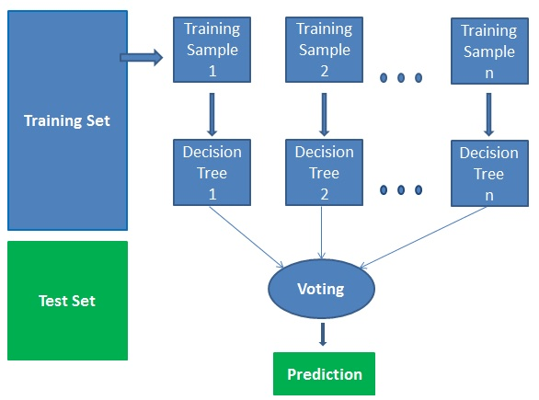

**Figure 1.** Random Forest Model

**1.1.2 *Minimum Distance:***

Make a most limited way tree (SPT) with a root at the required source. Keep up two sets, one of which contains vertices that are as of now included within the shortest-path tree and the other of which contains vertices that are not however included. Discover a vertex that's within the other set (set not however included within the calculation) that's closest to the source at each organism.

**1.1.3 *Classification and Regression Technique (CART):***

Depending on the edge esteem of a property, the hubs within the choice tree are partitioned into sub nodes. With the help of the Gini Record basis, the CART [8, 18] algorithm does this by searching for the sub nodes' best homogeneity. The training set, the root hub, is partitioned into two by taking into consideration the finest quality and edge esteem. The subsets are moreover partitioned, agreeing to the same principle. This keeps going until either the tree has its last immaculate sub-set or has developed to its greatest number of clears out. It is additionally alluded to as tree pruning. The Figure 2 [24] underneath clarifies how the CART calculation works.

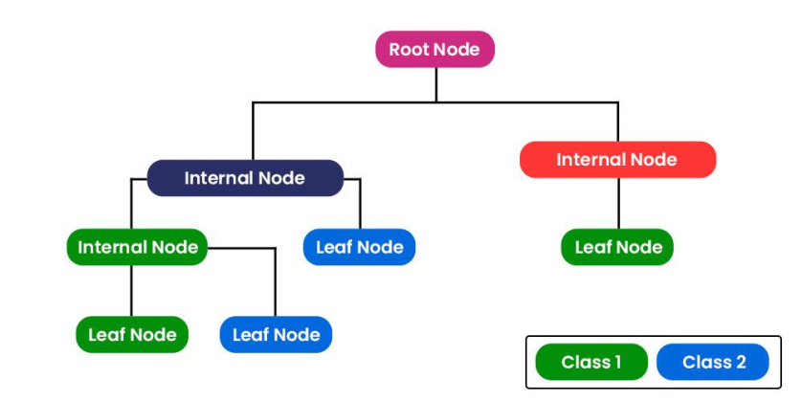

**Figure 2.** Classification and Regression Tree Model

**1.1.4 *Naive Bayesian (NB):***

Gullible Bayes could be a probabilistic calculation utilized for classification assignments in machine learning. It is based on Bayes' hypothesis [7, 9, 13, 25] which depicts the likelihood of a theory based on earlier information and modern evidence. The calculation works by evaluating the prior likelihood of each lesson name within the preparing information. At that point, for each highlight within the data, it gauges the likelihood of that highlight happening given each course name. This is often known as the conditional likelihood. To classify an unused information point, the calculation calculates the back likelihood of each lesson name given the watched highlights utilizing Bayes' hypothesis. The course name with the most elevated likelihood is at that point allotted to the modern information point.

P (A | B) = P(A|B) P(A)

P(B)

**1.2 *Google Earth Engine (GEE):***

Google Earth Engine (GEE)[15, 18, 37] is a cloud-based platform for analyzing, processing, and visualizing geospatial data. The platform combines satellite imagery, geospatial data sets, and machine learning algorithms to provide a comprehensive view of the Earth's surface and its changes over time. Users can access a wide range of datasets, including satellite imagery, climate data, topography data, and land cover data.

One of the main advantages of GEE is its ability to process large amounts of data quickly and efficiently, using Google's cloud computing infrastructure. This allows users to run complex analyses and generate visualizations in real-time, without the need for expensive hardware or software. The platform has been used for a variety of applications including land cover mapping, deforestation monitoring, crop yield prediction, and disaster response. It has also been used by governments and organizations to monitor and manage natural resources, such as water and forests. Google Earth Engine is a powerful platform for geospatial data analysis and visualization, with a wide range of applications in environmental monitoring, resource management, and research.

***Applications of Google Earth Engine (GEE):***

1. Can be used to detect and monitor deforestation and forest degradation, providing valuable insights into the health and status of the world's forests.

2. Provides access to a wide range of datasets, including satellite imagery, climate data, topography data, and land cover data. This makes it easier for researchers and policymakers to access and analyze the data they need.

3. Provides near-real-time access to data, which means that users can quickly access information on environmental and ecological changes as they happen.

4. Can be used to map land cover and land use changes over time, helping researchers and policymakers to better understand the impacts of human activities on the environment.

**1.2.1 *Vegetation Layer***

The vegetation layer in Land Use Land Cover (LULC) [5, 6, 7, 8] refers to a component of land cover that represents the presence and distribution of plant species across a given area. Vegetation cover is an important aspect of land use analysis and provides valuable information on the ecological and environmental characteristics of a region. The vegetation layer in LULC can be represented using a variety of methods, including satellite imagery, aerial photography, and ground surveys. Vegetation indices, such as the Normalized Difference Vegetation Index (NDVI), can also be used to estimate the density and health of vegetation cover across a landscape. The vegetation layer in LULC can provide valuable information on a variety of factors, including: Ecosystem health, Habitat suitability, Carbon sequestration, Soil erosion.

**1.2.2 *Edge Detection***

Edge detection is a process in digital image processing that aims to identify boundaries between objects and regions in an image. The goal is to identify areas of the image where the brightness, colour, or texture changes abruptly, which typically correspond to edges in the image. It is a technique in image processing and computer vision that aims to identify the boundaries between different objects and regions within an image. The edges in an image are the points where the brightness or color values change abruptly, indicating a boundary between different objects or regions. There are several algorithms used for edge detection, Sobel operator, Canny edge detector, Laplacian of Gaussian (LoG).

**2. Related Work**

Topaloğlu et al. [4] focused on evaluating the classification accuracies of two satellite data sources, namely Sentinel-2 and Landsat-8, for land cover and land use mapping. Classification accuracy refers to the ability of a classification algorithm to correctly assign classes to pixels or areas in a remotely sensed image. The study compares the performance of Sentinel-2 and Landsat-8 data in terms of their classification accuracies. It aims to assess which satellite data source provides more accurate results for land cover and land use mapping applications. The authors likely conducted experiments using different classification algorithms and techniques to evaluate the accuracies. To obtain their results, the authors have used reference data or ground truth information to validate the classified images generated from the satellite data. They have compared the classified images with the ground truth data to measure the accuracy of the classification results.

Sarma K.K. et al. [10] worked on the mapping of bamboo resources using satellite technology. Bamboo is a valuable natural resource with diverse applications, and mapping its distribution and extent can be important for various purposes such as resource management, conservation, and planning. To accomplish the mapping of bamboo resources, the authors likely utilized satellite imagery and remote sensing techniques. They have selected a study area or region where bamboo grows and collected satellite data, such as high-resolution imagery or multi-spectral data, for analysis. The authors likely processed the satellite data and applied image classification techniques to identify and map areas of bamboo coverage. They have used various image processing and classification methods, such as supervised or unsupervised classification, to differentiate bamboo from other land cover types. The article discusses the methodology and techniques employed to map bamboo resources using satellite technology. It also provides insights into the accuracy of the mapping results, the challenges encountered in the process, and the potential applications of the bamboo resource map.

Axelsson et al. [13] studied and came to a conclusion on the classification of tree species using Sentinel-2 imagery and Bayesian inference. The authors explored the potential of using Sentinel-2 satellite data, which provides high spatial and spectral resolution, for accurately identifying and classifying tree species. The study likely involves collecting spectral and spatial information from Sentinel-2 imagery for different tree species. The authors have selected specific study areas or forests where they gathered ground truth data to train and validate their classification models. The authors likely applied Bayesian inference techniques, a statistical method that uses prior knowledge and observations to make probabilistic inferences, to classify the tree species based on the Sentinel-2 imagery. Bayesian inference allows for the incorporation of prior information and helps improve the accuracy of the classification results.

Qi Shuhua & Song et al. [37] mapped bamboo using remote sensing images over a large area. It was challenging because of the similarity between bamboo and other vegetation types, the availability of clear optical images, huge workload of image processing, and sample collection. In this study, Landsat 8 times series images archive to map bamboo forests in China via the Google Earth engine are used. Several spectral indices were calculated and used as classification features, including the normalized difference vegetation index (NDVI), the normalized difference moisture index (NDMI) and textural features of the gray-level co-occurrence matrix (GLCM). The bamboo forest covered an area of 709.92 × 104 hectares, with the provinces of Fujian, Jiangxi, and Zhejiang containing the largest area concentrations. The bamboo forest map was accurate and reliable with an average producer’s accuracy of 89.970.7789. In addition, bamboo was mainly distributed in forests with an elevation of 300–1200 m above sea level, average annual precipitation of 1200–1500 mm and average day land surface temperature of 19–25 ◦C. The NDMI is particularly useful in differentiating bamboo from other vegetation because of the clear difference in canopy moisture content, whilst NDVI and elevation are also helpful to improve the bamboo classification accuracy. The bamboo forest map will be helpful for bamboo forest industry planning and could be used for evaluating the ecological service of the bamboo forest.

Adugna et al. [35] compared the performance of two classification algorithms, Random Forest (RF) and Support Vector Machine (SVM), for regional land cover mapping using coarse-resolution FY-3C satellite images. The authors investigate which algorithm provides more accurate results for mapping land cover at a regional scale. To conduct the study, the authors likely obtained FY-3C satellite images, which are characterized by coarse spatial resolution. They may have selected a specific region or area of interest for land cover mapping and collected ground truth data or reference information to validate their classification results. The authors likely applied both the RF and SVM classifiers to the FY-3C images and evaluated their performance in terms of accuracy and ability to map different land cover types. RF and SVM are both popular machine learning algorithms used for classification tasks in remote sensing. The comparison between RF and SVM classifiers may involve assessing various aspects such as overall accuracy, class-specific accuracies, error matrices, and other evaluation metrics. The authors may have also analyzed the strengths and limitations of each classifier in the context of regional land cover mapping using coarse-resolution satellite images.

Thanh Noi, P. et al. [34] performed a research on comparing the performance of three popular classification algorithms, namely Random Forest (RF), k-Nearest Neighbour (k-NN), and Support Vector Machine (SVM), for land cover classification using Sentinel-2 imagery. The authors aim to evaluate which algorithm provides better results for classifying land cover types based on the Sentinel-2 satellite data. To conduct the study, the authors likely obtained Sentinel-2 imagery, which is known for its high spatial and spectral resolution, and selected a study area or region for land cover classification. They have collected ground truth data or reference information to validate the accuracy of the classification results. The authors likely applied the RF, k-NN, and SVM classifiers to the Sentinel-2 imagery and compared their performance in terms of accuracy, efficiency, and the ability to accurately classify different land cover classes. These classifiers are commonly used in remote sensing for land cover classification tasks. The comparison between RF, k-NN, and SVM classifiers involves assessing various performance metrics such as overall accuracy, kappa coefficient, user's and producer's accuracies, and other evaluation measures. The authors have also discussed the advantages and limitations of each classifier for land cover classification using Sentinel-2 imagery.

Shao, Y., et al. [8] have done a work based on the performance of three classification algorithms, namely Support Vector Machine (SVM), Neural Network (NN), and CART (Classification and Regression Trees), for land-cover classification when limited training data points are available. The authors aimed to assess which algorithm performs better in situations where the amount of labelled training data is insufficient. To conduct the study, the authors likely collected remote sensing data, such as satellite imagery, for land-cover classification. They have faced the challenge of limited labelled training data, which is common in many remote sensing applications. The study has focused on finding an effective solution for accurate land-cover classification despite having a limited number of training samples. The authors applied the SVM, NN, and CART algorithms to the limited training data points and evaluated their performance in terms of accuracy and robustness.

Tang Y. et al. [17] explored the ability of WorldView-2 (WV-2) imagery for bamboo mapping in a mountainous region in Sichuan Province, China. A large area of this place is covered by shadows in the image, and only a few sampled points derived were useful. In order to identify bamboos based on sparse training data, the sample size was expanded according to the reflectance of multispectral bands selected using the principal component analysis (PCA). Then, class separability based on the training data was calculated using a feature space optimization method to select the features for classification. Four regular object based classification methods were applied based on both sets of training data. The results showed that the k-nearest neighbour (k-NN) method produced the greatest accuracy. A geo-statistically weighted k-NN classifier, accounting for the spatial correlation between classes, was then applied to further increase the accuracy. It achieved 82.65producer’s and user’s accuracies respectively for the bamboo class. The canopy densities were estimated to explain the result. This study demonstrated that the WV-2 image can be used to identify small patches of under-story bamboos given limited known samples, and the resulting bamboo distribution facilitates the assessments of the habitats of giant pandas.

**3. Study Area and Data**

**3.1 *Study Area***

Assam, located in the north-eastern region of India, is known for its rich biodiversity and natural resources. Assam's bamboo forests cover a vast area of the state and provide livelihoods to many people living in the region. Assam is one of the top bamboo-growing regions in India, with a diverse range of bamboo species found in the state. The state's climate and topography make it an ideal location for the cultivation of bamboo, with many districts specializing in bamboo cultivation and production. Karbi Anglong district is known for its bamboo-based industries, such as the production of bamboo flooring, furniture, and handicrafts. The district is home to a variety of bamboo species, including Bhaluka, Betua, and Muli.Dima Hasao district, located in the southern part of Assam, is known for its significant contribution to the bamboo industry in the state. Karbi Anglong is surrounded by an area of approximately 10,434 square kilometres. The latitude of Karbi Anglong district in Assam, India is between 25.11° N to 26.98° N and the longitude is between 92.10° E to 94.55° E. Dima Hasao, also known as North Cachar Hills, is a district located in the state of Assam, India. The district covers an area of approximately 4,888 square kilometres. The latitude of Dima Hasao district is between 25.3333° N to 26.3333° N and the longitude is between 92.5° E to 94.5° E. The figure 3 shows the study region considered in this study i.e. the districts of Karbi Anglong and Dima Hasao of Assam, India.

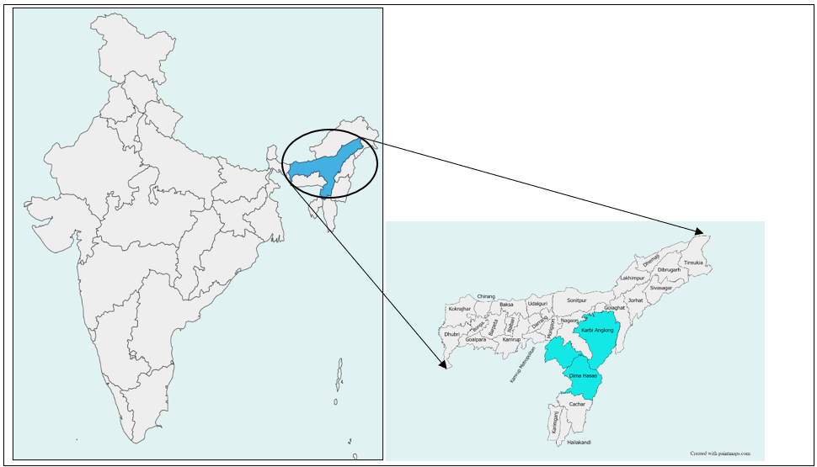

**Figure 3.** Study region Karbi Anglong and Dima Hasao - Districts of Assam Region

**3.2 *Dataset***

The Sentinel-2[13, 27] satellite dataset is a useful resource for analyzing land cover mapping in various regions, including Karbi Anglong and Dima Hasao districts of Assam, India. The Sentinel-2 satellite images provide high spatial and spectral resolution data that can be used to identify and map different land features, including forests, fallow land, water, pure bamboo, mixed bamboo and dominated bamboo. The Sentinel-2 dataset provides an important resource for studying and managing land use and land cover changes in Karbi Anglong and Dima Hasao districts, and can support informed decision-making for sustainable development and natural resource management. The figure 4 illustrates the data set region i.e. the districts of Assam where bamboo cultivation is more, covered by cloud layer.

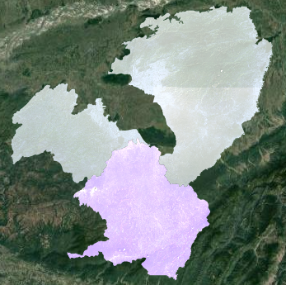

**Figure 4.** Study area Karbi Anglong and Dima Hasao covered by cloud layer

**4. Methodology**

Google Earth Engine has quick and effective access to and analysis of substantial amounts of LULC data. The platform includes tools and methods for processing and analyzing the data. Scalability is one of the main advantages of using Google Earth Engine for LULC research. The platform's ability to analyze a large amount of data makes it especially helpful for keeping track of significant environmental changes, such deforestation, urbanization, and climate change. Moreover, Google Earth Engine offers a simple user interface for viewing and analyzing geospatial data. The Sentinel-2 images of the study area are collected and the features are benign collected from the training area using the training dataset. The Karbi Anglong area is said to be trained and the Dima Hasao is being tested. The complete study area is said to be classified. The complete project is divided into 5 modules containing the sub modules. The figure 5 clearly depicts the architecture of the whole project of bamboo mapping and classification.

* Module 1: Sentinel-2 image/ shape file
* Module 2: Image collection
  + Sub Module 1: Filter By Location
  + Sub Module 2: Filter By Date
  + Sub Module 3: Filter By Boundaries
* Module 3: Feature extraction
* Module 4: Classification
  + Sub Module 1: Selection of test are
  + Sub Module 2: Applying the Supervised technique
  + Sub Module 3: Classified Image is generated
* Module 5: Mapping
  + Sub Module 1: Classified Image
  + Sub Module 2: Vegetation Layer
  + Sub Module 3: Edge Detection
  + Sub Module 4: Area Calculation
  + Sub Module 5: Accuracy Assessment

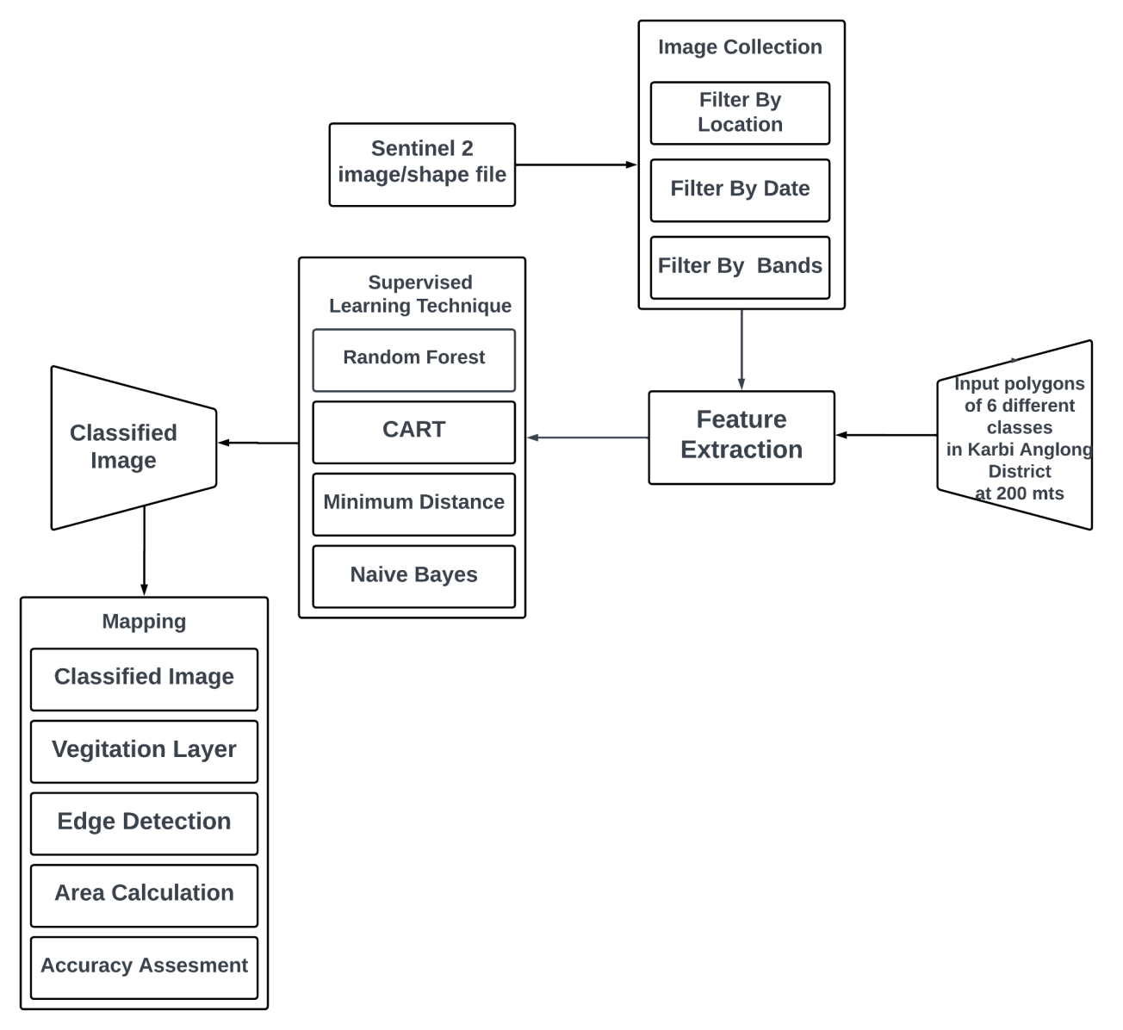

**Figure 5.** Proposed architecture for bamboo mapping

**4.1 *Dataset Collection***

Sentinel-2 is a satellite system developed by the European Space Agency (ESA) that captures high-resolution optical images of the Earth's surface. The Sentinel-2 data is freely available and can be accessed through the Copernicus Open Access Hub. We can access and analyze Sentinel-2 data through the Google Earth Engine platform, which provides a suite of tools for processing and analyzing geospatial data. The sentinel 2 layer is added as a map view layer which is around 10 to 20 meters resolution and visualizes the images in different bands and indices. by using filter by location Karbi Anglong as the training area and Dima Hasao (North Cachar Hills) as the testing region in the duration of start of march to end of march month by considering the bands of B4,B5,B8.

**4.2 *Collecting the training samples***

In Google Earth Engine we extract the feature using the Feature extraction. Feature extraction in Google earth engine helps in analyzing and extracting information of geospatial data. In this technique we define polygons over the regions of Karbi Anglong and Dima Hasao and extract data within those polygons, such as the spectral properties of vegetation, land cover type, and other geospatial features. A collection of 1,081 polygons of 6 different features and the polygons taken in the resolution of 200 meters are being considered. AS increase in the number of classes and the number of polygons the accuracy of each particular feature is calculated accurately. The considered features are:

* Fallow Land - 101 polygons -
* Water - 99 polygons - Rivers or Any source of Water
* Pure Bamboo - 298 polygons- Region with complete 100% Bamboo
* Mixed Bamboo - 301 polygons - Region with Bamboo and Other tree species
* Dominated Bamboo - 181 polygons - Region surrounded by 60% to 80 % Bamboo
* Forest - 101 polygons - Region with different species of plants/trees

**4.3 *Classification Phase***

The area considered in the data collection and the training samples are considered and are applied to required supervised learning algorithms. The techniques used in this paper are Random Forest (RF) , Minimum Distance, Classification and regression Trees (CART), Naive Bayes (NB). The area is taken as the input region and the training samples are used to classify the required features and on applying the required algorithm the classified image is being generated. Each pixel in the polygons used to classify land cover class based on its spectral properties. Each feature can be visualized by their respective colors.

**4.4 *Area Calculation and Mapping***

Accuracy assessment mainly helps in evaluating the performance of a land cover classification of bamboo and other features. It calculates the area by validating required polygons and confusion matrices are generated. Validation polygons are ground truth polygons used to assess the accuracy of a classification in the study area - Karbi Anglong (training area). Required algorithm is used for classification of features and thus extracting the features. This involves aggregating the pixel values within a defined radius around each validation point. Classified land cover with the ground truth data is compared and the confusion matrix is being generated. The classification generates a colour coded map that shows the accuracy of each land cover class.

**4.5 *Vegetation Layer and Edge Detection***

The classification area generated from the classification phase contains all the classes. The particular feature that can be made to visualize is said to be the vegetation layer. Detecting the boundaries of the particular required feature can be done by using Gaussian edge detection methodology. The GUI developed indicates a button called vegetation layer and edge detection on selecting the required feature button the particular feature is visualized. On selecting the required we can see vegetation layer or edge detection layer or vegetation and edge detection combined layer of a particular feature. The figure 6 shows us the Interface built for selection of different methods for classification.

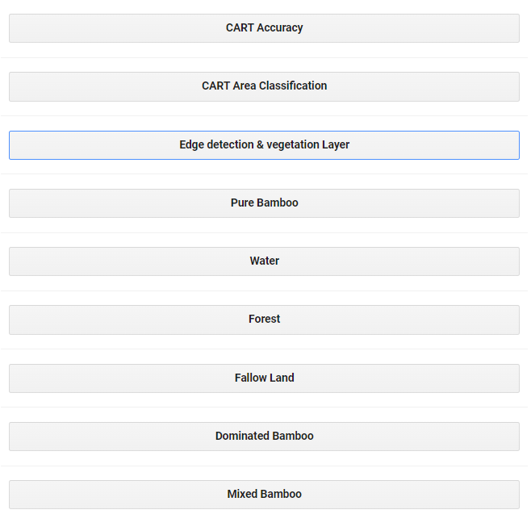

**Figure 6.** Interface of different methods for classification

**5. Results and Discussion**

The figure 7 represents 1,081 polygons of 6 different classes for the testing region (Karbi Anglong). There are 101 polygons for fallow land, 99 polygons for water, 298 polygons for pure bamboo, 301 polygons for mixed bamboo, 301 polygons for mixed bamboo, 181 polygons for dominated bamboo and 101 polygons for forest are all located in Karbi Anglong region. The feature is being extracted from the training polygons and classification is done.

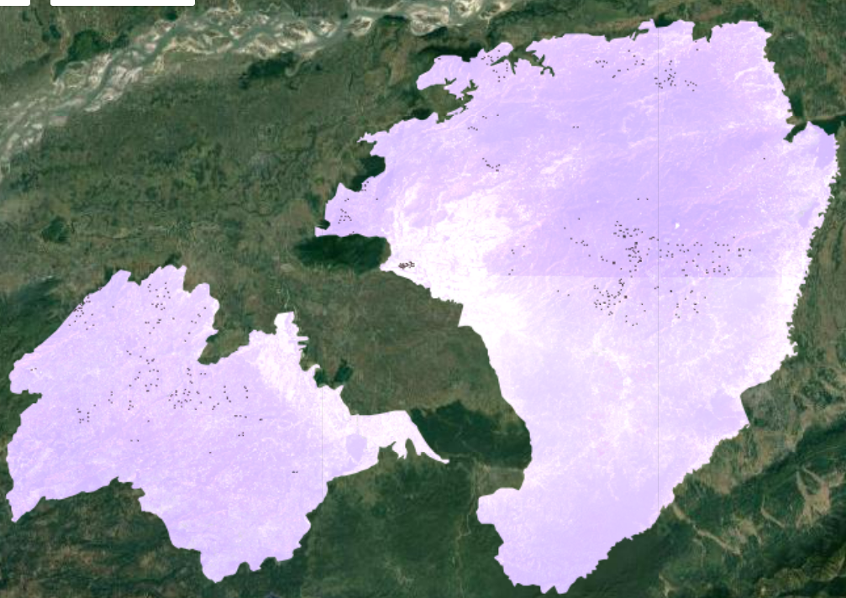

**Figure 7.** Training polygons located in the Karbi Anglong

The console is present in the Google earth engine platform. **Figure 8** shows the buttons of selecting the required region, the regions considered are Karbi Anglong as the training region and Dima Hasao as the testing region. On selecting the required region different algorithms are shown.

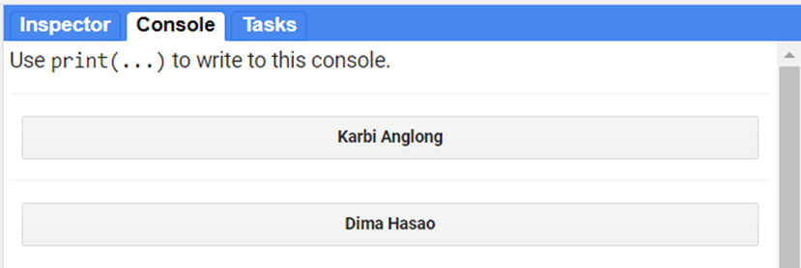

**Figure 8.** Console displaying the buttons of the regions Karbi Anglong and Dima Hasao

**Figure 9** displaying the 4 different algorithms where the required algorithm needs to be selected to further classification of the above selected region. And thus a classification layer will be generated above the selected region. The generated layer is said to be the classified layer.

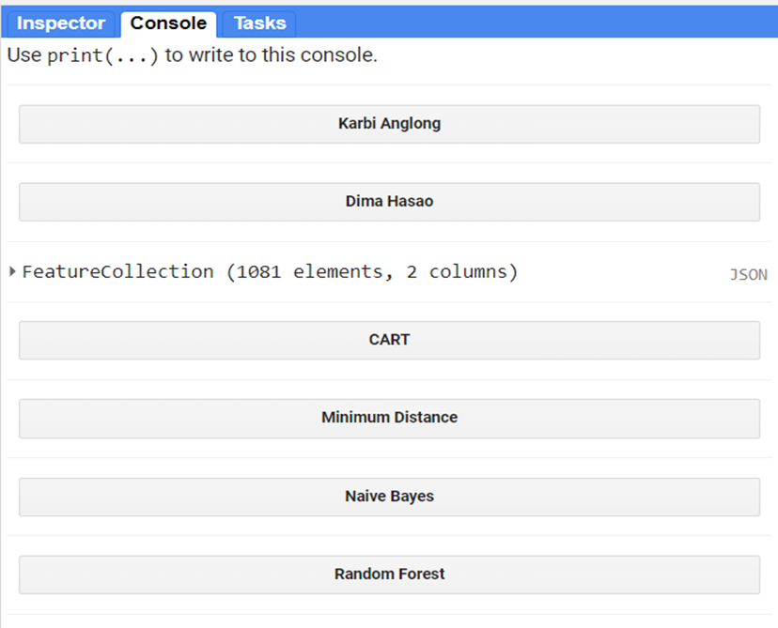

**Figure 9.** Different supervised algorithms for segmentation

Selecting the algorithm adds a classified image layer to the map above the satellite image layer. Classification performed on KarbiAnglong using CART, SVM, NB, and RF produces the results as shown in **Figures 10, and 11**. As observed in the figures the classification images of CART and RF look similar. The colors on the map depict the different features that are classified. The light green color on the map represents bamboo, red represents pure bamboo, dark green represents forests, purple represents fallow land, black represents bare soil and blue represents water bodies.

On selecting the region sentinel-2 layer is generated above the satellite layer, a classification layer is generated on selecting the required algorithm. The classification is made based on 6 classes each class representing a different color.

1. Forest - Navy Green
2. Water - Rich Blue
3. Fallow Land - Magenta
4. Pure Bamboo - Lemon Green
5. Mixed Bamboo - Sunny Yellow
6. Dominated Bamboo - Red

The figure 11 represents the classification made by using the algorithms Random Forest and Naive Bayes. The random forest generates an accuracy of 92.69% and Naive bayes generates an accuracy of 35%.

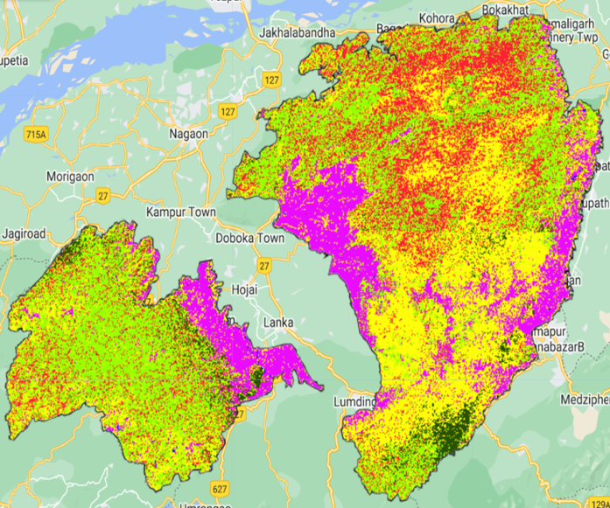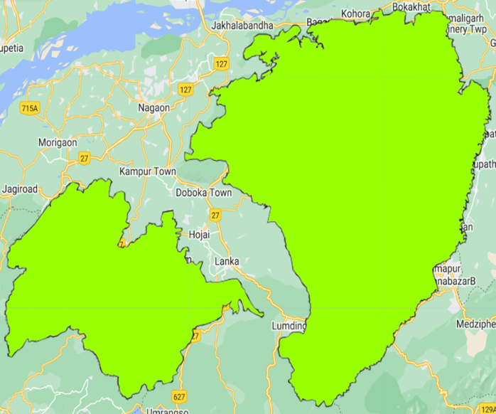

**Figure 10.** Classified layer generated by using Random Forest & Naive Bayes algorithms

The **Figure 11** represents the classification made by using the algorithms CART and Minimum Distance. The CART generates an accuracy of 93.4% and Minimum Distance generates an accuracy of 32.7%.

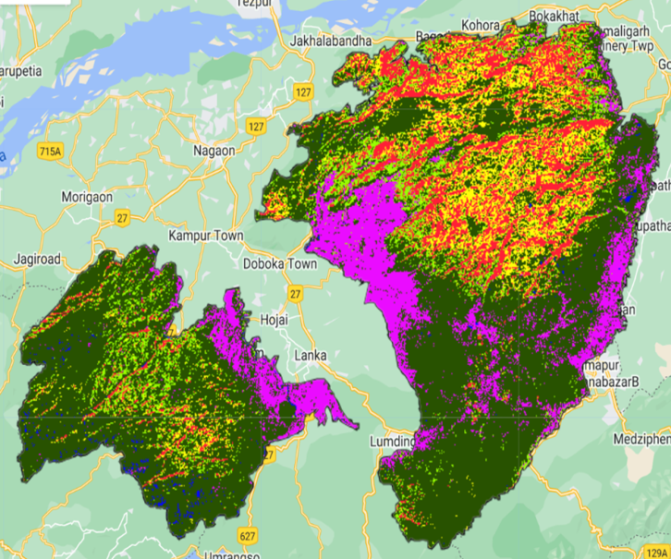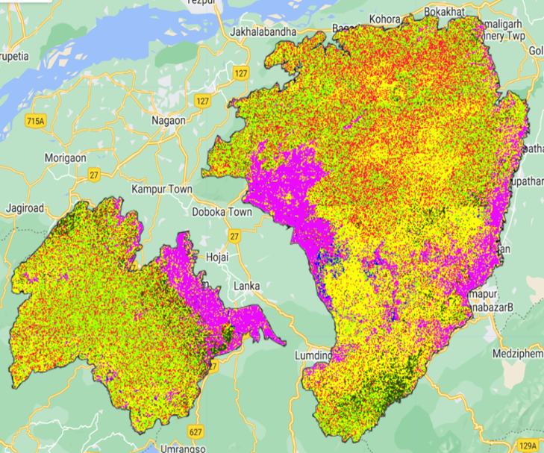

**Figure 11.** Classified layer generated by using Minimum distance & CART

Figure 10, 11 represents the classification layer generated in the testing region - Dima Hasao Using the classification algorithms. The **Figure 12** represents the classification made by using the algorithms Random Forest and Naive Bayes. The random forest generates an accuracy of 94.78% and Naive bayes generates an accuracy of 48.69%.

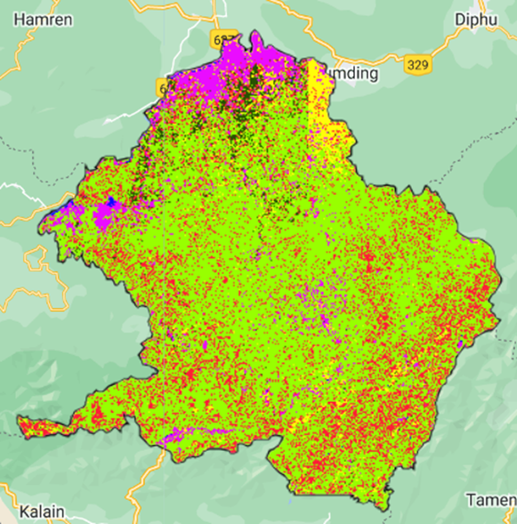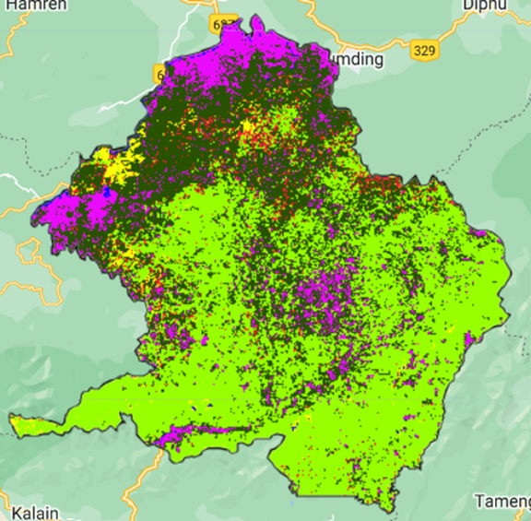

**Figure 12.** Classified layer generated by using Random Forest & Naive Bayes algorithms for Dima Hasao region

The **Figure 13** represents the classification made by using the algorithms CART and Minimum Distance. The CART generates an accuracy of 94.98% and Minimum Distance generates an accuracy of 39.5%.

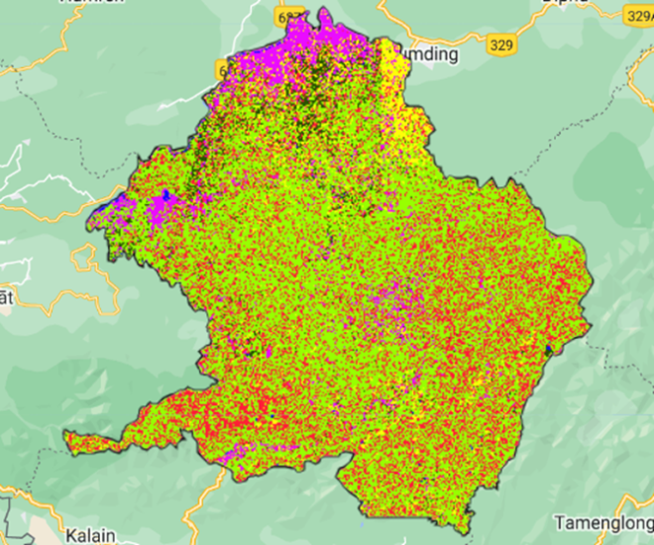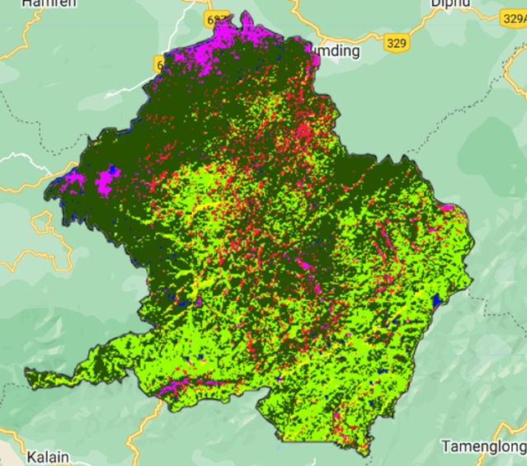

**Figure 13.** Classified layer generated by using CART & Minimum distance for Dima Hasao Region

The number of true samples with respect to the complete samples indicates how accurately an algorithm performs the classification. The Confusion matrix gives the accurate classification for every class. The **Figure 14**, **15** represent the accuracy obtained and the area of each class in the particular selected region. The graph generated in the console represents the area covered by each class in that particular region with the km² on applying the algorithms CART, Random Forest, Minimum Distance, Naive Bayes.

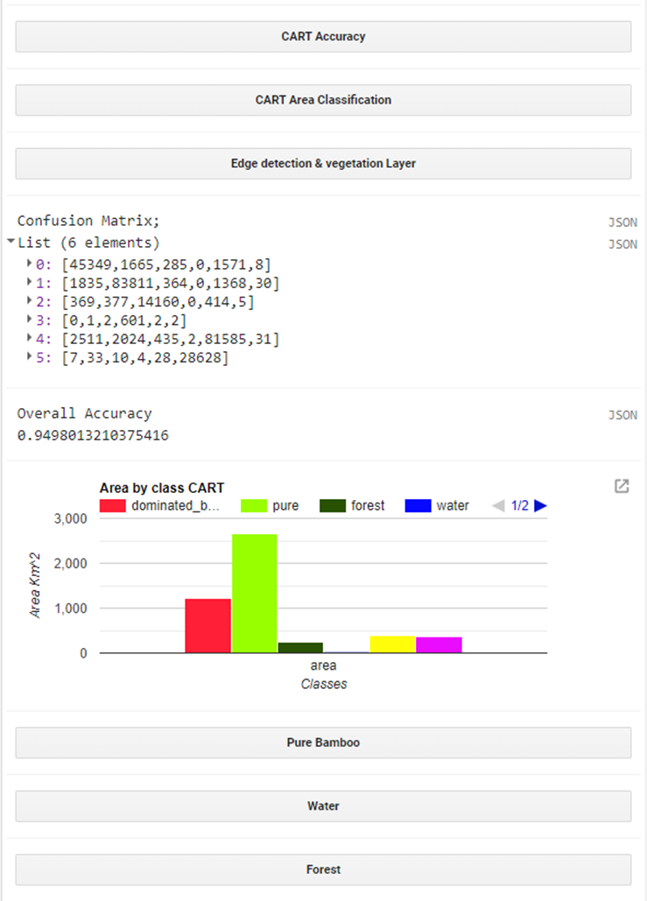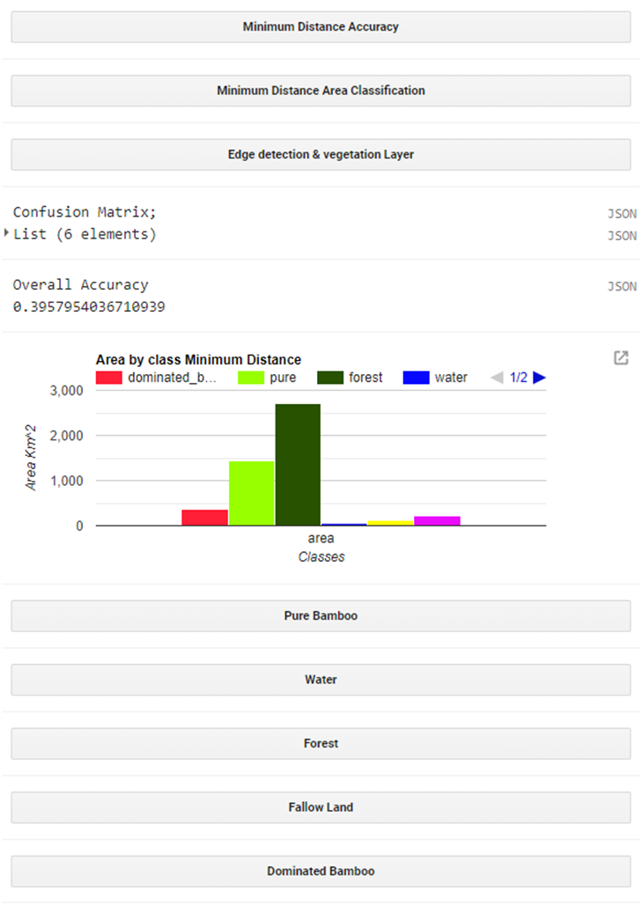

**Figure 14.** Area Calculations for CART and Minimum Distance algorithms

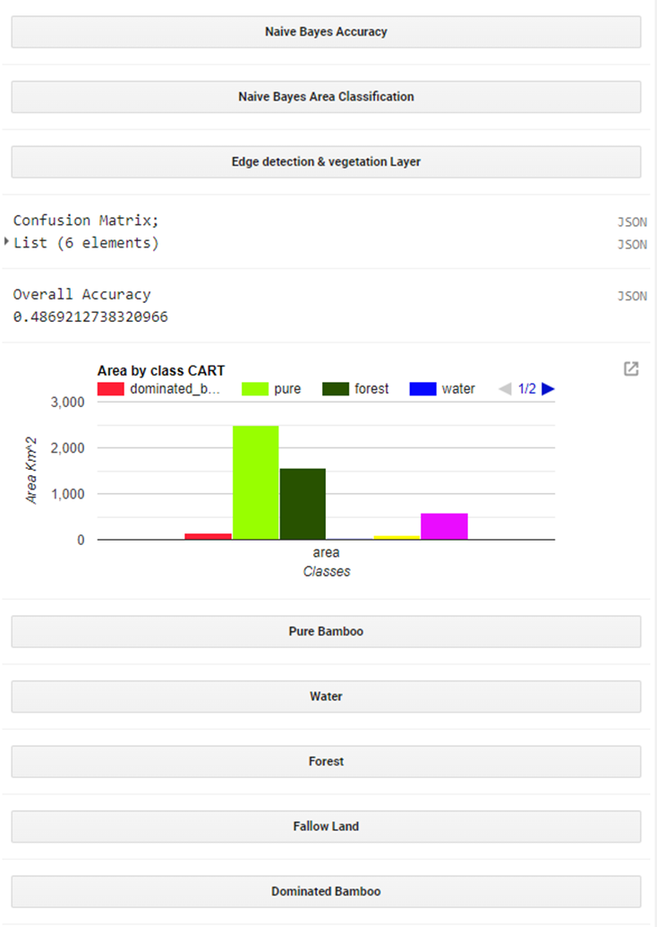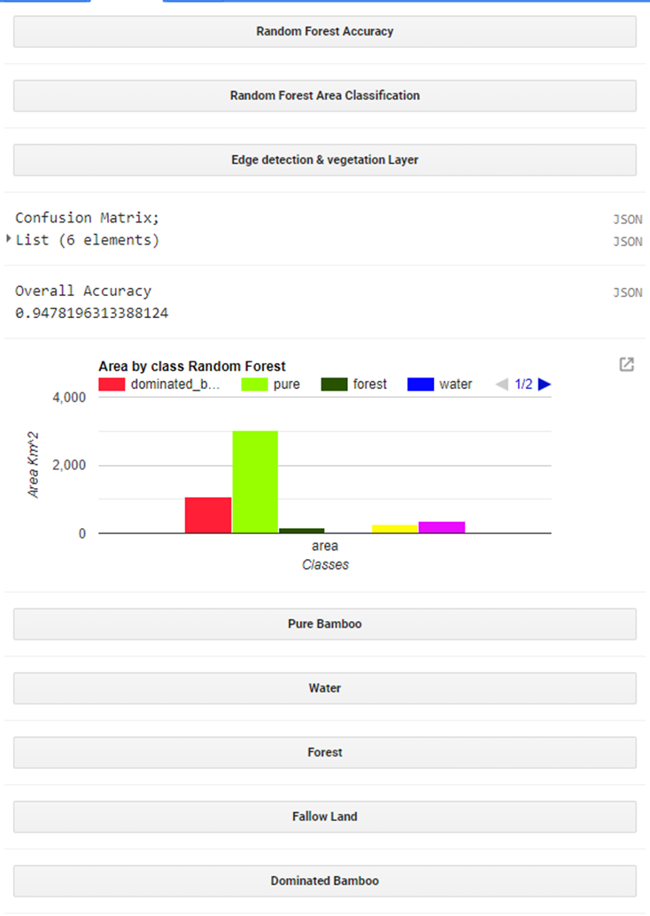

**Figure 15.** Area Calculations for Naive Bayes and Random Forest algorithms

The **Figures 16,17,18,19** represent the particular feature layer generated. In edge detection any pixel in the bottom, right, or diagonal bottom-right pixel that has the opposite sign is referred to as a zero-crossing. The current pixel is set to 1 (zero-crossing) if any of these pixels have the opposite sign; otherwise, it is set to 0. The zero-crossings algorithm can be used for edge detection. The pure bamboo edge detection and vegetation layer are shown in the Figure 16. The mixed bamboo edge detection and vegetation layer are shown in the Figure 17. The dominated Bamboo edge detection and vegetation layer are shown in the Figure 18. The water edge detection and vegetation layer are shown in the Figure 19. The forest edge detection and vegetation layer are shown in the Figure 20. The fallow Land edge detection and vegetation layer are shown in the Figure 21.

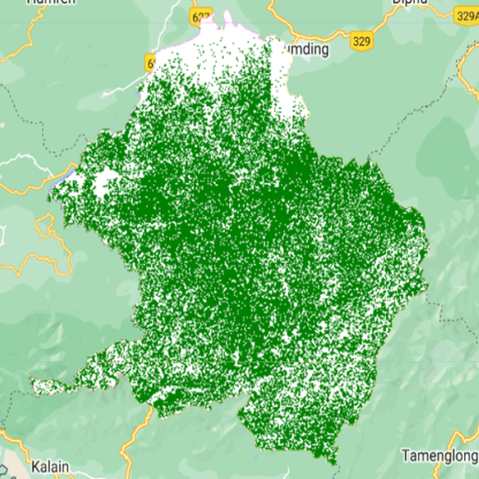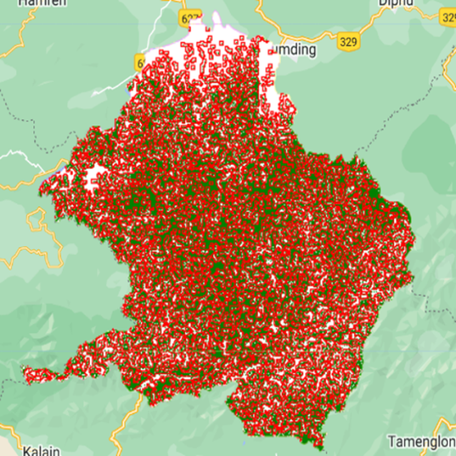

**Figure 16.** Vegetation layer & Edge detection of Pure bamboo in Dima Hasao region

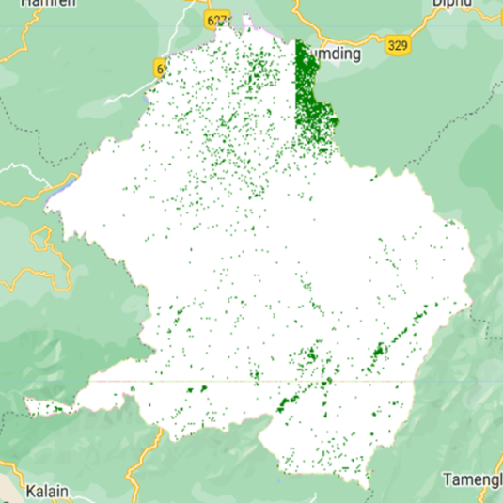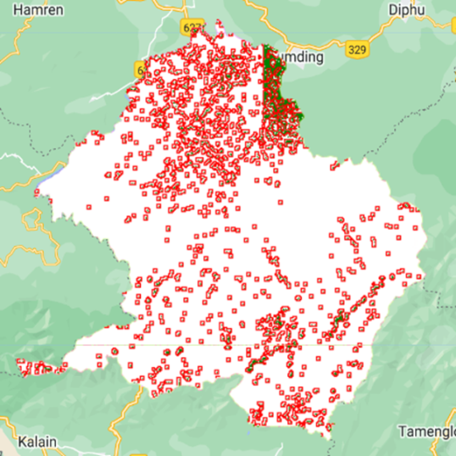

**Figure 17.** Vegetation layer & Edge detection of Mixed bamboo in Dima Hasao region

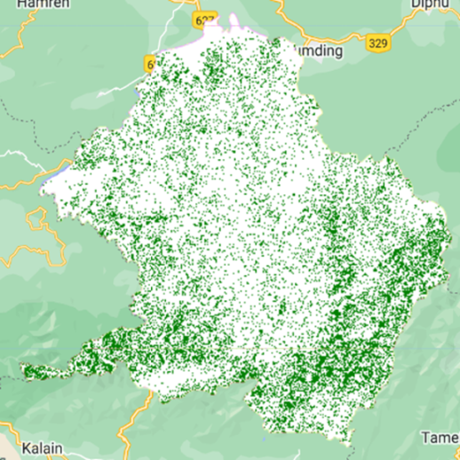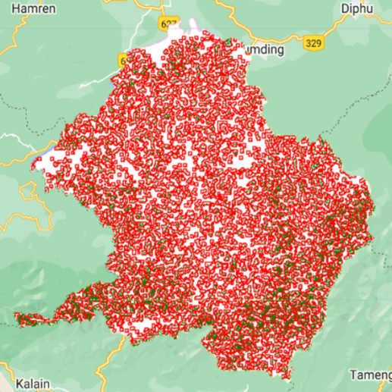

**Figure 18.** Vegetation layer & Edge detection of Dominated Bamboo in Dima Hasao region

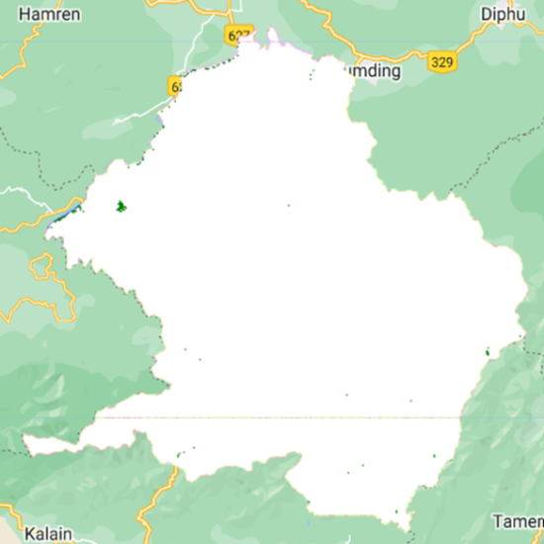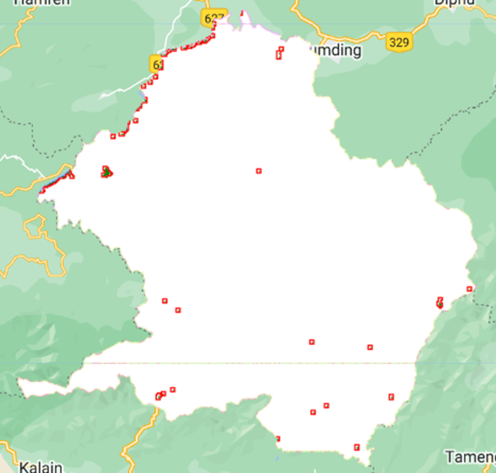

**Figure 19.** Vegetation layer & Edge detection of Water in Dima Hasao region

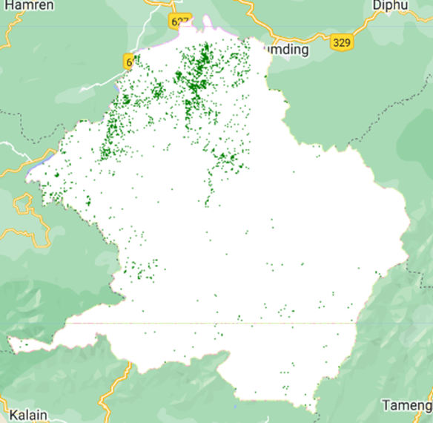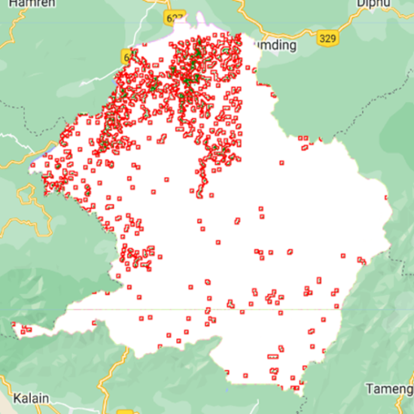

**Figure 20.** Vegetation layer & Edge detection of Forest in Dima Hasao region

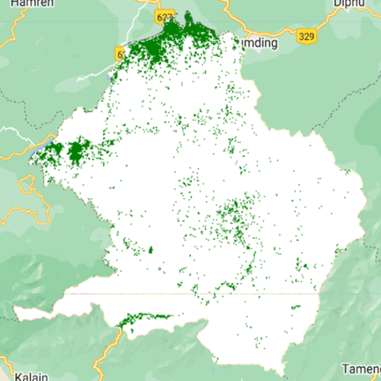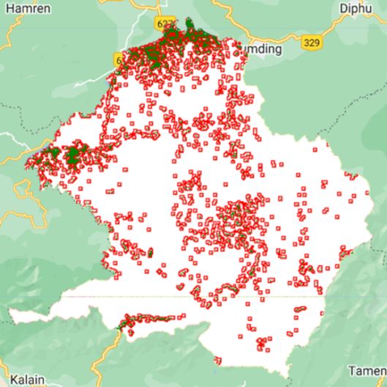

**Figure 21.** Vegetation layer & Edge detection of Fallow Land in Dima Hasao region

***Accuracy Assessment***

It is the method of assessing the precision of an arrival cover classification. It compares the classified information to ground truth information, which speaks to the true arrival cover within the think about region. In general exactness created is the percentage of accurately classified polygons out of the entire number of polygons within the consider zone. User's exactness is the extent of accurately classified polygons for a particular lesson, whereas producer's precision is the extent of genuine polygons of a particular course that were accurately classified. Precision evaluation can help decide the by and large precision of an arrival cover classification and makes a difference to recognize ranges where the classification should be improved.

Accuracy = Number of true predictions

Total predictions

An exactness evaluation for Dima Hasao's classified regions has been performed here. The disarray network for the CART, RF, Least separate, and NB classifiers were created by employing an add up of 1081 polygons. The regions that were precisely classified are spoken to by the corner to corner components. The whole number of accurately classified regions is calculated, and the entire number of reference polygons is partitioned to decide the by and large precision. The perplexity network created by the GEE code editor is utilized for calculating measurements such as Review, Exactness, and F1 Score.

**F1 - score:**

The F-score, commonly known as the F1-score, could be a model's precision on a dataset. It is utilized to evaluate twofold classification frameworks, which categorize cases as 'positive' or 'negative'. The F1 score may be a machine learning assessment metric that gauges the precision of a demonstration. It combines a model's exactness and review scores. The precision measurement calculates how numerous times a show is anticipated accurately over the total dataset. The formula of the F1- score with respect to the recall and precision is shown in Equation (3).

(Recall * Precision) (3)

F1 – Score = ~~---------------------------------~~

(Recall + Precision)

**Recall & Precision:**

Calculating review includes partitioning all positive tests by the division of accurately categorized Positive tests. The review metric surveys the model's capacity to recognize positive tests. When the review was higher, there were more positive tests found. The genuine positives and genuine negatives from the disarray lattice obtained for the classification are utilized to calculate the review. Though exactness, or the standard of a great expectation, is another measurement for surveying a model's viability. Accuracy is calculated by isolating the entire number of positive forecasts by the extent of genuine positives.

True positive

Recall = ~~-------------------------------------~~ (4)

(True Positive + False Negative)

True positive

Precision = ~~------------------------------------------- --~~ (5)

(True Positive + False Positive)

Using Equations (4) & (5), recall and precision are calculated respectively using which F1 – score is finally obtained. The tabular form of the calculated results is shown in the following chapter.

**6. Comparative Analysis**

Six separate classes present in the Dima Hasao region after applying all four classification techniques, the complete area generated is 10,426 km and area for each class as shown in **Table1, 2**. Table1 represents six separate classes present in the Karbi Anglong region after applying all four classification techniques the complete area generated is an area for each class as shown in Table1.

|  |  |  |  |  |
| --- | --- | --- | --- | --- |
| **Algorithm/ Feature** | **Random Forest(RF)** | **Minimum Distance** | **Classification and Regression Tree(CART)** | **Naive Bayes(NB)** |
| **Dominated Bamboo** | 1,845.99 | 1,375.39 | 1,949.65 |  |
| **Pure Bamboo** | 3,345.20 | 825.646 | 2,991.58 | 10,426.61 |
| **Mixed Bamboo** | 3,268.79 | 906.121 | 3,379.53 |  |
| **Water** | 21.69 | 106.805 | 34.81 |  |
| **Forest** | 411.164 | 5,841.29 | 565.297 |  |
| **Fallow Land** | 1,533.78 | 1,371.37 | 1,505.75 |  |
| **Total** | 10,426.614 | 10,426.622 | 10,426.617 | 10,426.61 |

**Table 1.** Area for Karbi Anglong

|  |  |  |  |  |
| --- | --- | --- | --- | --- |
| **Algorithm/ Feature** | **Random Forest(RF)** | **Minimum Distance** | **Classification and Regression Tree(CART)** | **Naive Bayes(NB)** |
| **Dominated Bamboo** | 1,060.36 | 356.48 | 1,221.43 | 143.948 |
| **Pure Bamboo** | 3,038.62 | 1,450.58 | 2,662.41 | 2,497.81 |
| **Mixed Bamboo** | 266.446 | 116.285 | 398.188 | 91.567 |
| **Water** | 17.893 | 53.58 | 22.099 | 19.627 |
| **Forest** | 160.054 | 2,709.44 | 231.893 | 1,562.57 |
| **Fallow Land** | 367.42 | 224.431 | 374.773 | 595.277 |
| **Total** | 4910.793 | 4910.796 | 4910.793 |  |

**Table 2.** Area for Dima Hasao

The algorithms used are CART, Minimum distance, Random Forest (RF), Naive Bayes the accuracies generated are shown in **Table 3**. On complete analysis of the accuracies generated by different algorithms on training and testing areas the Random Forest and CART shows the more accurate results. Random Forest generates an accuracy of 92.69% and CART an accuracy of 93.413% in the training area - Karbi Anglong. Whereas in Testing area - Dima Hasao the Random Forest generates an accuracy of 94.78% and CART an accuracy of 94.98%.

| **Areas/ Algorithms** | **KarbiAnglong** | **DimaHasao** |
| --- | --- | --- |
| **Random Forest** | 92.698% | 94.78% |
| **Minimum Distance** | 32.74% | 39.57% |
| **CART** | 93.413% | 94.98% |
| **Naive Bayes** | 35.65% | 48.69% |

**Table 3.** Accuracy obtained on applying different algorithms on both training and testing regions.

**7. Conclusion and Future work**

This demonstration illustrates the utilization of the supervised learning methods and the Google Earth Engine. The entire study makes a difference for the user to classify and compare the bamboo type within the specific locale. The models used are part of the supervised learning methods, as the approach and functions change accordingly. The other advantage that has been proven is the usage of Google Earth Engine (GEE) as this platform has been used for a variety of applications, including land cover mapping, deforestation monitoring, crop yield prediction, and disaster response. The Polygon and point comparison done in this study also demonstrated many results. The Edge location process utilized digital image processing that identified vegetation boundaries. This study also included a comparison of the regions of each class with their ground truth values. To conclude, the CART and Random forest attained higher accuracy of 94.78% and 94.98% respectively and gave the most accurate classification of 6 different classes on performing with the polygon plots. Among the polygons and points that were compared, polygons have proven to be the best due to the proximity of the region assessed.

The polygon-based classification provides a more comprehensive representation of land cover features compared to point-based classification and can handle complex and irregularly shaped land cover features more effectively. This difference affects the accuracy of each method when points and polygons are considered. This study also includes a comparison of the regions of each class with their ground truth values. In comparison the CART and Random forest attained higher accuracy of 94.78% and 94.98% and were given the most accurate classification of 6 different classes.

As it is evident from the results that the usage of polygons and the models CART and Random forest gave the most noteworthy conceivable accuracy, As part of future work, the increment in the number of polygons and classes to run the model can be done so that the accurate results can be obtained. The comparison between the ground truth values and the obtained values can be done for perfection and error-free analysis.

**References**

1. Du, H., Mao, F., Li, X., Zhou, G., Xu, X., Han, N., ... & Zhou, Y. (**2018**). Mapping global bamboo forest distribution using multisource remote sensing data. *IEEE Journal of Selected Topics in Applied Earth Observations and Remote Sensing*, *11*(5), 1458-1471.
2. Farah, D. A., Dharmawan, A., & Novianti, V. (**2021**). Bamboo Distribution Map for Planning the Development of Tourism Potential in Boon Pring Andeman Area. *Proceedings of the National Institute of Ecology of the Republic of Korea*, *2*(3), 144-152.
3. Zhou, G., Ni, Z., Zhao, Y., & Luan, J. (**2022**). Identification of Bamboo Species Based on Extreme Gradient Boosting (XGBoost) Using Zhuhai-1 Orbita Hyperspectral Remote Sensing Imagery. *Sensors*, *22*(14), 5434.
4. Topaloğlu, R. H., Sertel, E., & Musaoğlu, N. (**2016**). Assessment of Classification Accuracies of Sentinel - 2 and Landsat - 8 data for Land cover/use mapping. *International archives of the photogrammetry, remote sensing & spatial Information Sciences*, *41*.
5. Shi, D., & Yang, X. (**2015**). Support vector machines for land cover mapping from remote sensor imagery. *Monitoring and Modeling of Global Changes: A Geomatics Perspective*, 265-279.
6. Rudrapal, D., & Subhedar, M. (**2015**). Land cover classification using support vector machine. *Int. J. Eng. Res*, *4*(09), 584-588.
7. Pradhan, R., Ghose, M. K., & Jeyaram, A. (**2010**). Land cover classification of remotely sensed satellite data using bayesian and hybrid classifier. *International Journal of Computer Applications*, *7*(11), 1-4.
8. Shao, Y., & Lunetta, R. S. (**2012**). Comparison of support vector machine, neural network, and CART algorithms for the land-cover classification using limited training data points. *ISPRS Journal of Photogrammetry and Remote Sensing*, *70*, 78-87.
9. Sitthi, A., Nagai, M., Dailey, M., & Ninsawat, S. (**2016**). Exploring land use and land cover of geotagged social-sensing images using naive bayes classifier. *Sustainability*, *8*(9), 921.
10. Goswami, J., Tajo, L., & Sarma, K. K. (**2010**). Bamboo resources mapping using satellite technology. *Current Science*, 650-653.
11. Nfornkah, B. N., Rene, K., Martin, T., Louis, Z., Cedric, C., & Armand, T. (**2020**). Assessing the spatial distribution of bamboo species using remote sensing in Cameroon. *Journal of Ecology and the Natural Environment*, *12*(4), 172-183.
12. Dida, J. J. V., Araza, A. B., Eduarte, G. T., Umali, A. G. A., Malabrigo Jr, P. L., & Razal, R. A. (**2021**). Towards nationwide mapping of bamboo resources in the Philippines: testing the pixel-based and fractional cover approaches. *International Journal of Remote Sensing*, *42*(9), 3380-3404.
13. Axelsson, A., Lindberg, E., Reese, H., & Olsson, H. (**2021**). Tree species classification using Sentinel-2 imagery and Bayesian inference. *International Journal of Applied Earth Observation and Geoinformation*, *100*, 102318.
14. Zhao, L., Luo, W., Liao, Q., Chen, S., & Wu, J. (**2022**). Hyperspectral image classification with contrastive self-supervised learning under limited labeled samples. *IEEE Geoscience and Remote Sensing Letters*, *19*, 1-5.
15. Poortinga, A., Thwal, N. S., Khanal, N., Mayer, T., Bhandari, B., Markert, K., ... & Saah, D. (**2021**). Mapping sugarcane in Thailand using transfer learning, a lightweight convolutional neural network, NICFI high-resolution satellite imagery and Google Earth Engine. *ISPRS Open Journal of Photogrammetry and Remote Sensing*, *1*, 100003.
16. Lozano-Garzon, C., Bravo-Córdoba, G., Castro, H., González-Rodríguez, G., Niño, D., Nuñez, H., ... & Suárez, L. I. (**2022**). Remote Sensing and Machine Learning Modeling to Support the Identification of Sugarcane Crops. *IEEE Access*, *10*, 17542-17555.
17. Tang, Y., Jing, L., Li, H., Liu, Q., Yan, Q., & Li, X. (**2016**). Bamboo classification using worldview-2 imagery of giant panda habitat in a large shaded area in Wolong, Sichuan province, China. *Sensors*, *16*(11), 1957.
18. Bittencourt, H. R., & Clarke, R. T. (**2003**, July). Use of classification and regression trees (CART) to classify remotely-sensed digital images. In *IGARSS 2003. 2003 IEEE International Geoscience and Remote Sensing Symposium. Proceedings (IEEE Cat. No. 03CH37477)* (Vol. 6, pp. 3751-3753). IEEE.
19. Anthony, G., Greg, H., & Tshilidzi, M. (**2007**). Classification of images using support vector machines. *arXiv preprint arXiv:0709.3967*.
20. Rohith Gandhi, Support Vector Machine Introduction to Machine Learning Algorithms <https://towardsdatascience.com/support-vector-machine-introduction-to-machine-learning-algorithms-934a444fca47>.
21. Breiman, L. (**2001**). Random forests. *Machine learning*, *45*, 5-32.
22. Qian, Y., Zhou, W., Yan, J., Li, W., & Han, L. (**2014**). Comparing machine learning classifiers for object-based land cover classification using very high resolution imagery. *Remote Sensing*, *7*(1), 153-168.
23. Random Forest Algorithm, last accessed on 12-01-2023, Available Online at: Github https://github.com/geekquad/Random-Forest-from-Scratch. Last accessed on
24. CART algorithm, Geeks for Geeks, last accessed on 12-01-2023, Available Online at: [https://www.geeksforgeeks.org/cart-classification-and-regression-tree-in-machine-learning](https://www.geeksforgeeks.org/cart-classification-and-regression-tree-in-machine-learning/)
25. Naive bayes algorithm, last accessed on 12-01-2023, Available Online at: Databasecamp https://databasecamp.de/en/ml/naive-bayes-algorithm
26. Dhruv5819, Geeks For Geeks, Naive Bayes Classifier, last accessed on 12-01-2023, Available Online at: https://www.geeksforgeeks.org/naive-bayes-classifier-in-r-programming/.
27. Alshari, E. A., & Gawali, B. W. (**2022**). Analysis of Machine Learning Techniques for Sentinel-2A Satellite Images. *Journal of Electrical and Computer Engineering*, *2022*.
28. Gorelick, N., Hancher, M., Dixon, M., Ilyushchenko, S., Thau, D., & Moore, R. (**2017**). Google Earth Engine: Planetary-scale geospatial analysis for everyone. *Remote sensing of Environment*, *202*, 18-27.
29. Oliva, F. E., Dalmau, O. S., & Alarcón, T. E. (**2014**). A supervised segmentation algorithm for crop classification based on histograms using satellite images. In *Human-Inspired Computing and Its Applications: 13th Mexican International Conference on Artificial Intelligence, MICAI 2014, Tuxtla Gutiérrez, Mexico, November 16-22, 2014. Proceedings, Part I 13* (pp. 327-335). Springer International Publishing.
30. Gualtieri, J. A., & Cromp, R. F. (**1999**, January). Support vector machines for hyperspectral remote sensing classification. In *27th AIPR workshop: Advances in computer-assisted recognition* (Vol. 3584, pp. 221-232). SPIE.
31. Immitzer, M., Atzberger, C., & Koukal, T. (**2012**). Tree species classification with random forest using very high spatial resolution 8-band WorldView-2 satellite data. *Remote sensing*, *4*(9), 2661-2693.
32. Pal, M. (**2005**). Random forest classifier for remote sensing classification. *International journal of remote sensing*, *26*(1), 217-222.
33. Foody, G. M. (**2002**). Status of land cover classification accuracy assessment. *Remote sensing of environment*, *80*(1), 185-201. [31]
34. Thanh Noi, P., & Kappas, M. (**2017**). Comparison of random forest, k-nearest neighbor, and support vector machine classifiers for land cover classification using Sentinel-2 imagery. *Sensors*, *18*(1), 18.
35. Adugna, T., Xu, W., & Fan, J. (**2022**). Comparison of random forest and support vector machine classifiers for regional land cover mapping using coarse resolution FY-3C images. *Remote Sensing*, *14*(3), 574.
36. S.Nivetha, Dr.R.Jensi" Classification, and Comparison of Remote Sensing Image using Support Vector Machine and K-Nearest NeighborAlgorithms."Advances in Engineering: an International Journal (ADEIJ)(**2015**). Available Online at: https://airccse.com/adeij/papers/2319adeij03.pdf.
37. Qi, S., Song, B., Liu, C., Gong, P., Luo, J., Zhang, M., & Xiong, T. (**2022**). Bamboo forest mapping in China using the dense Landsat 8 image archive and Google Earth Engine. *Remote Sensing*, *14*(3), 762.
38. Ghosh, A., & Joshi, P. K. (**2014**). A comparison of selected classification algorithms for mapping bamboo patches in lower Gangetic plains using very high-resolution WorldView 2 imagery. *International Journal of Applied Earth Observation and Geoinformation*, *26*, 298-311.